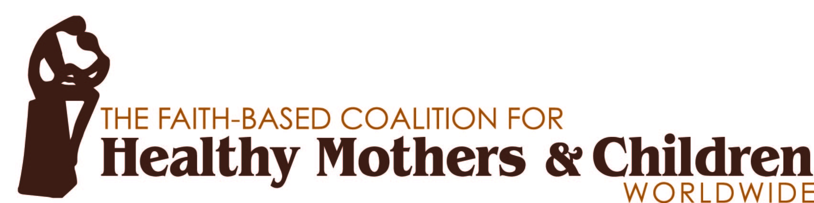
March 13, 2015

Congressman Hal Rogers
2406 Rayburn House Office Building
Washington, DC 20515

Senator Thad Cochran
110 Dirksen Senate Office Building
Washington, D.C., 20510

Senator Lindsey Graham
437 Russell Senate Office Building
Washington, DC 20510

Congresswoman Kay Granger
1026 Longworth House Office Building
Washington, DC 20515

Congresswoman Nita Lowey
2365 Rayburn House Office Building
Washington, D.C. 20515

Senator Barbara Mikulski
503 Hart Senate Office Building
Washington, DC 20510

Senator Patrick Leahy
290 Russell Senate Office Building
Washington, DC 20510

Dear Chairman Rogers, Ranking Member Lowey, Chairman Cochran, Ranking Member Mikulski, Chairwoman Granger, Chairman Graham and Ranking Member Leahy:

We write to you on behalf of the Faith-Based Coalition for Healthy Mothers and Children Worldwide to thank you for your ongoing leadership in Congress in support of global maternal and child health programs. Specifically, we request that you provide robust funding in the FY 2016 appropriations process for U.S. programs that support maternal, newborn, and child health (MNCH) and healthy timing and spacing of pregnancies (HTSP) with existing legislative safeguards.

Our coalition seeks to galvanize faith-based leaders and their constituencies around the issues of MNCH, including HTSP, to improve maternal health and reduce child mortality. When women and girls lack access to the education and resources they need to create a healthy plan for becoming mothers, the result is tragic: 289,000 women in developing nations die from preventable complications during childbirth, and 6.3 million children die before their fifth birthday each year.
We recognize the difficult decisions you face in a constrained budget environment, but we know the truly life-saving impact of U.S. investments in women and children. We respectfully request that you make U.S. programs for global maternal, newborn, and child health and family planning a priority as you develop your FY 2016 Appropriations bills.
As people of faith we believe that we all have a duty to do what is within our power to help these women and their families to achieve their potential through improved health.
Sincerely,

Kenny Alphin Artist (Big & Rich) Nashville, TN
Andi Ashworth Editor, Art House America Nashville, TN
Walter August, Jr. Author, Sr. Pastor & Chairman of Bethel’s Family Church Houston, TX
Stephan Bauman CEO and President, World Relief Baltimore, MD
Steve Berger Sr. Pastor, Grace Chapel Leipers Fork, TN
Chris Bolton CEO, Blood:Water Nashville, TN
Annette Bourland Sr. VP & Group Publisher, Zondervan Grand Rapids, MI
Colleen Buroughs Founder, Watering Malawi Birmingham, AL
Tony Campolo, PhD Author & Speaker, Eastern University St. David’s, PA
Mary Beth Chapman Author Brentwood, TN
Steven Curtis Chapman Artist Brentwood, TN
Jennifer Cooke Manager, Amy Grant Nashville, TN
Chaz Corzine Manager, The MWS Group Franklin, TN
Jenny Eaton Dyer ED, Hope Through Healing Hands Nashville, TN
Gary L Edmonds President/CEO, Food for the Hungry Phoenix, AZ
Bill Frist , MD Chairman, Hope Through Healing Hands Nashville, TN
Gary Furr, PhD Pastor, Vestavia Hills Baptist Church Birmingham, AL
Mike Glenn Sr. Pastor, Brentwood Baptist Church Brentwood, TN
Amy Grant Artist Nashville, TN
Garrett Grigsby Executive Director, Vienna, VA
Christian Connections for International Health
Tracie Hamilton Philanthropist & Mother Franklin, TN
Scott Hamilton Olympic Gold Medalist & Philanthropist Franklin, TN
Dan Haseltine Artist, Jars of Clay Franklin, TN
Esther Havens Humanitarian Photographer Dallas, TX
Larry Hollon General Secretary, United Methodist Communications Nashville, TN
Marcus D. Holman Missions Pastor & President of Bethel’s Family Church
Global Reach Houston, TX
Velvet Kelm President, The {M}edia Collective Franklin, TN
Terry Laura, RN, MPH Health Technical Advisor, Compassion International Colorado Springs, CO
Charlie Lowell Artist, Jars of Clay Nashville, TN
Ray Martin Emeritus ED, Christian Connections for International Health Sterling, VA
Joe McIlhaney, MD Founder and Chair, The Medical Institute for Sexual Health Plano, TX
Brian McLaren Author & Speaker Marco Island, FL
Santiago “Jimmy” Mellado President, Compassion International Colorado Springs, CO
David Moberg SVP & Group Publishing, HarperCollins Christian Publishing Nashville, TN
Bill Mugford Former Pastor, HIV&AIDS Initiative, Saddleback Church Lake Forest, CA
James Nardella Executive Director, Lwala Community Alliance Nashville, TN
Jena Lee Nardella Co-Founder, Blood:Water &Author Nashville, TN
Jennifer Nettles Artist (Sugarland) Nashville, TN
Lindsey Nobles COO, If: Gathering Austin, TX
Kimberly Williams Paisley Actor & Philanthropist Franklin, TN
J. Jeffrey Palmer Executive Director, Baptist Global Response Nashville, TN
Charlie Peacock Music Producer & Artist-in-Residence, Lipscomb University Nashville, TN
Rev. Edwin Sanders II Sr. Servant, Metropolitan Interdenominational Church Nashville, TN
Scott Sauls Sr. Pastor, Christ Presbyterian Church Nashville, TN
Dan Scott Sr. Pastor, Christ Church Nashville Nashville, TN
Rev. Sarah Shelton Sr. Pastor, Baptist Church of the Covenant Birmingham, AL
Lott Shudde Manager, Third Day Brentwood, TN
Anita Smith President, Childrens AIDS Fund Washington, DC
Michael W. Smith Artist Franklin, TN
Shepherd Smith President, International Youth Development Washington, DC
Richard Stearns President, World Vision US Federal Way, WA
David Stevens, MD, MA CEO, Christian Medical and Dental Associations Bristol, TN
Sherry Surratt CEO and President, MOPS International Colorado Springs, CO
Cathy Taylor Dean & Professor, Belmont University Nashville, TN
Steve Taylor Recording Artist & Filmmaker Nashville, TN
Third Day Christian Band Atlanta, GA
Larry Thompson Pastor, First Baptist Church Fort Lauderdale Fort Lauderdale, FL
David Vanderpool Founder, LiveBeyond Thomazeau, Haiti
Jim Wallis President and Founder, Sojourners Washington, DC
John Walter President, African Leadership Brentwood, TN
Stefanie Weiland Executive Director, LifeNet International Orlando, FL
Jessica Wolstenholm Author & Co-Founder, Grace for Moms Nashville, TN

